

Computer’s Science

Career: Information Technology Engineering

Modality: Online

URI Layout

Team3 DevSolutions

Mantilla Sarauz Diego Andrés (Leader) Loachamin Aldaz Esteban Mateo Maldonado Miranda Erick Gabriel Maldonado Paredes Ligia Maricela

Subject:

Web Applications Development

NRC: 8516

Tutor: Edison Lascano.
1.

URI Layout

Product

Method | post
URI | http://3.85.13.59:3003/iSoftware/addProduct
Body | 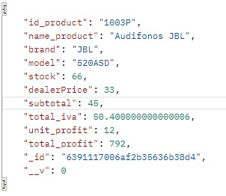
Format | Json
Return

Method | get
URI | http://3.85.13.59:3003/iSoftware/listProducts
Body | 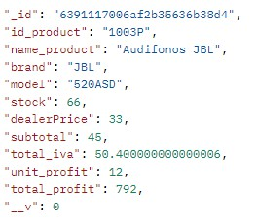
Format | Json
Return

Method | put
URI | http://3.85.13.59:3003/iSoftware/updateProducts
Body | id_product: { type: String }
Format | Json
Return | 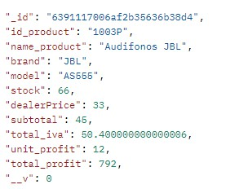

Method | delete
URI | http://3.85.13.59:3003/iSoftware/deleteProduct
Body | id_product: { type: String }
Format | Json
Return | Deleted

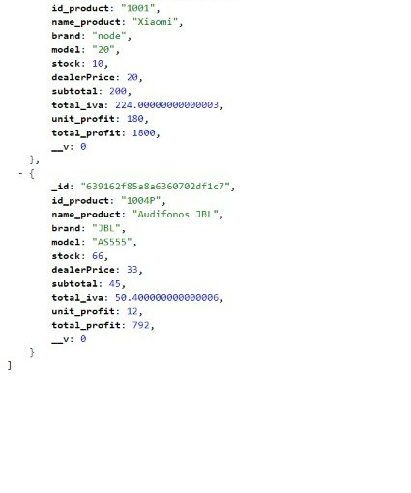
User

Method | post
URI | http://3.85.13.59:3003/iSoftware/addUser
Body | 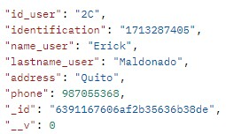
Format | Json
Return

Method | get
URI | http://3.85.13.59:3003/iSoftware/listUsers
Body | 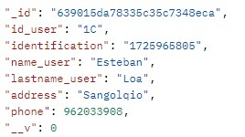
Format | Json
Return

Method | put
URI | http://3.85.13.59:3003/iSoftware/lupdateUser
Body | id_user: { type: String }
Format | Json

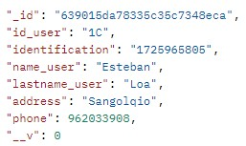

Method | delete
URI | http://3.85.13.59:3003/iSoftware/deleteUser
Body | id_user: { type: String }
Format | Json
Return | Deleted

Order

Method | post
URI | http://3.85.13.59:3003/iSoftware/addOrder
Body | 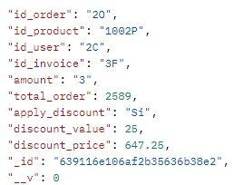
Format | Json
Return

Method | get
URI | http://3.85.13.59:3003/iSoftware/listOrders
Body
Format | Json

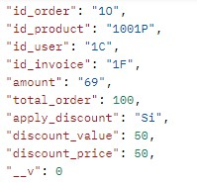

Method | put
URI | http://3.85.13.59:3003/iSoftware/updateOrder
Body | id_order: { type: String }
Format | Json
Return | 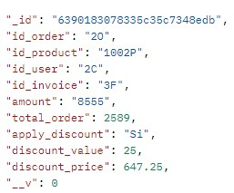

Method | delete
URI | http://3.85.13.59:3003/iSoftware/deleteOrder
Body | id_order: { type: String }
Format | Json
Return | Deleted

Invoice

Method | post
URI | http://3.85.13.59:3003/iSoftware/addInvoice

Body | 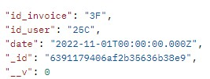
Format | Json
Return

Method | get
URI | http://3.85.13.59:3003/iSoftware/listInvoices
Body
Format | Json
Return | 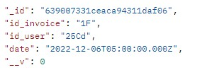

Method | put
URI | http://3.85.13.59:3003/iSoftware/updateInvoice
Body | id_invoice: { type: String }
Format | Json
Return

Method | delete
URI | http://3.85.13.59:3003/iSoftware/deleteInvoice
Body | id_invoice: { type: String }
Format | Json
Return | Deleted

